

Medical Radiation Practice Board of Australia

Registrant data

Reporting period: 1 January 2018 – 31 March 2018

Table of contents
Introduction 3
Principal place of practice 4
1. Registration type 4
2. Divisions 5
Age group 6
3. Registration type and subtype 6
4. Divisions 7
Gender 8
5. Registration type 8
6. Percentage 8

Introduction
The role of the Medical Radiation Practice Board of Australia (the Board) is to:
- register medical radiation practitioners and students
- develop standards, codes and guidelines for the medical radiation profession
- investigate notifications and complaints
- where necessary, conduct panel hearings and refer serious matters to Tribunal hearings
- oversee the assessment of overseas trained practitioners who wish to practise in Australia, and
- approve accreditation standards and accredited courses of study.
The Board’s functions are supported by the Australian Health Practitioner Regulation Agency (AHPRA). For information about legislation governing our operations see About AHPRA at www.ahpra.gov.au/About-AHPRA/What-We-Do/Legislation.aspx.
The Board has analysed its registration data and produced a number of statistical breakdowns about registrants to share with the profession and community. The Board shares these breakdowns regularly.
For more information on medical radiation practitioner registration, please see the Board’s website: www.medicalradiationpracticeboard.gov.au/Registration.aspx

Principal place of practice
- Registration type
  - Registration type and subtype by principal place of practice
Registration type | Subtype | ACT | NSW | NT | QLD | SA | TAS | VIC | WA | No PPP | Total
General |  | 262 | 5,064 | 99 | 3,232 | 1,208 | 318 | 3,752 | 1,327 | 235 | 15,497
Provisional |  | 3 | 264 | 7 | 57 | 4 | 2 | 106 | 6 | 1 | 450
Limited | Supervised practice |  |  |  |  | 1 |  |  |  |  | 1
Non-practising |  | 5 | 64 | 1 | 23 | 15 | 4 | 76 | 16 | 32 | 236
Total |  | 270 | 5,392 | 107 | 3,312 | 1,228 | 324 | 3,934 | 1,349 | 268 | 16,184

  - Registration type by principal place of practice percentages

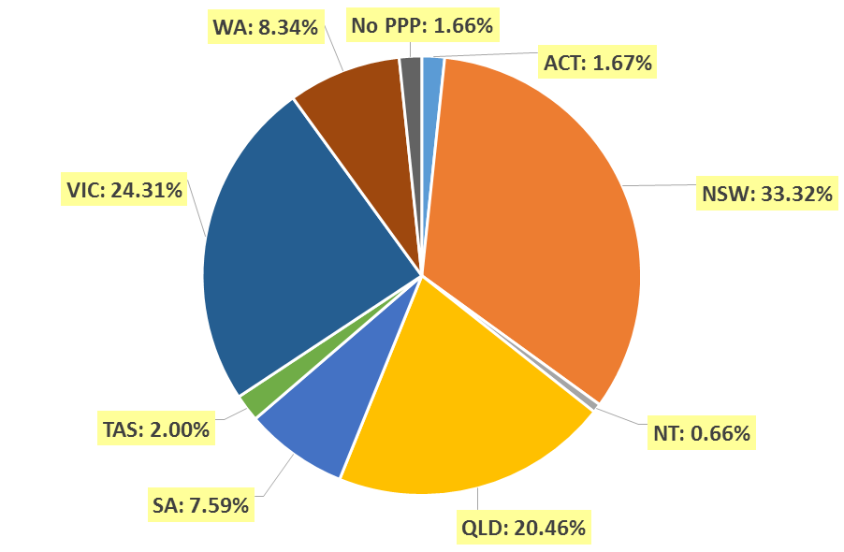

- Divisions
  - By area of division
Divisions | ACT | NSW | NT | QLD | SA | TAS | VIC | WA | No PPP | Total
Diagnostic Radiographer | 192 | 4,138 | 94 | 2,587 | 984 | 241 | 2,959 | 1,099 | 218 | 12,512
Diagnostic Radiographer and Nuclear Medicine Technologist |  | 2 |  | 10 | 1 | 1 | 1 | 2 |  | 17
Diagnostic Radiographer and Radiation Therapist |  |  |  | 1 |  |  | 1 |  |  | 2
Nuclear Medicine Technologist | 23 | 458 | 2 | 179 | 85 | 17 | 350 | 67 | 18 | 1,199
Radiation Therapist | 55 | 794 | 11 | 535 | 158 | 65 | 623 | 181 | 32 | 2,454
Total | 270 | 5,392 | 107 | 3,312 | 1,228 | 324 | 3,934 | 1,349 | 268 | 16,184

Age group
- Registration type and subtype
  - Registration by age group
Age Group | General | Provisional | Limited |  | Non-practising | Total
Age Group | General | Provisional | Post graduate training or supervised practice | Supervised Practice | Non-practising | Total
U - 25 | 1,327 | 285 |  |  | 3 | 1,615
25 - 29 | 2,969 | 99 |  |  | 38 | 3,106
30 - 34 | 2,834 | 27 |  |  | 44 | 2,905
35 - 39 | 2,091 | 20 |  |  | 48 | 2,159
40 - 44 | 1,626 | 10 |  |  | 38 | 1,674
45 - 49 | 1,390 | 5 |  |  | 16 | 1,411
50 - 54 | 1,061 | 2 |  |  | 11 | 1,074
55 - 59 | 1,054 | 2 |  |  | 16 | 1,072
60 - 64 | 779 |  |  | 1 | 11 | 791
65 - 69 | 299 |  |  |  | 6 | 305
70 - 74 | 53 |  |  |  | 5 | 58
75 - 79 | 13 |  |  |  |  | 13
80+ | 1 |  |  |  |  | 1
Total | 15,497 | 450 |  | 1 | 236 | 16,184

- Divisions
  - Divisions by age group
Age Group | Diagnostic Radiographer | Diagnostic Radiographer and Nuclear Medicine Technologist | Diagnostic Radiographer and Radiation Therapist | Nuclear Medicine Technologist | Radiation Therapist | Total
U - 25 | 1,189 |  |  | 173 | 253 | 1,615
25 - 29 | 2,381 | 1 |  | 255 | 469 | 3,106
30 - 34 | 2,121 |  |  | 217 | 567 | 2,905
35 - 39 | 1,597 | 4 |  | 183 | 375 | 2,159
40 - 44 | 1,270 | 3 | 1 | 124 | 276 | 1,674
45 - 49 | 1,107 | 5 | 1 | 100 | 198 | 1,411
50 - 54 | 905 | 2 |  | 55 | 112 | 1,074
55 - 59 | 903 | 2 |  | 43 | 124 | 1,072
60 - 64 | 686 |  |  | 38 | 67 | 791
65 - 69 | 283 |  |  | 10 | 12 | 305
70 - 74 | 56 |  |  | 1 | 1 | 58
75 - 79 | 13 |  |  |  |  | 13
80+ | 1 |  |  |  |  | 1
Total | 12,512 | 17 | 2 | 1,199 | 2,454 | 16,184

  - Registration by age group

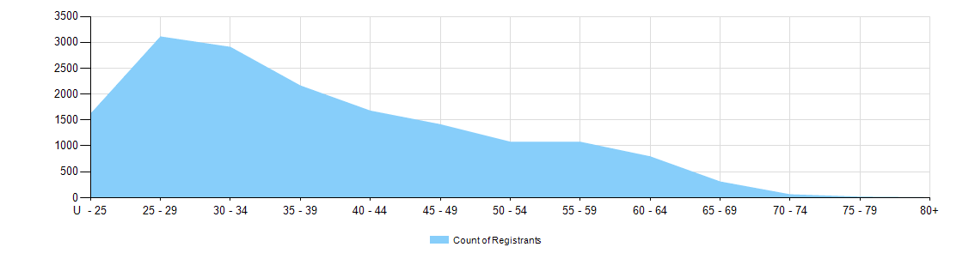

Gender
- Registration type
  - Registration type by gender
Gender | Registration Type | Subtype | ACT | NSW | NT | QLD | SA | TAS | VIC | WA | No PPP | Total
Female | General |  | 173 | 3,425 | 62 | 2,170 | 891 | 223 | 2,519 | 910 | 171 | 10,544
Female | Provisional |  |  | 172 | 5 | 38 | 2 | 2 | 76 | 6 |  | 301
Female | Limited | Supervised practice
Female | Non-practising |  | 5 | 44 | 1 | 19 | 14 | 4 | 54 | 14 | 26 | 181
Total Female |  |  | 178 | 3,641 | 68 | 2,227 | 907 | 229 | 2,649 | 930 | 197 | 11,026
Male | General |  | 95 | 1,633 | 37 | 1,067 | 310 | 98 | 1,218 | 418 | 56 | 4,932
Male | Provisional |  | 3 | 89 | 2 | 19 |  | 1 | 51 |  | 1 | 166
Male | Limited | Supervised practice |  |  |  |  | 1 |  |  |  |  | 1
Male | Non-practising |  |  | 20 |  | 5 | 1 |  | 23 | 5 | 7 | 61
Total Male |  |  | 98 | 1,742 | 39 | 1,091 | 312 | 99 | 1,292 | 423 | 64 | 5,160
Total |  |  | 280 | 5,362 | 103 | 3,320 | 1,190 | 329 | 3,946 | 1,340 | 280 | 16,150

- Percentage
  - Registration by gender percentages
Gender | ACT | NSW | NT | QLD | SA | TAS | VIC | WA | No PPP | Total
Female | 65.0% | 67.5% | 62.1% | 67.1% | 73.8% | 69.9% | 67.3% | 68.4% | 77.1% | 68.0%
Male | 35.0% | 32.5% | 37.9% | 32.9% | 26.2% | 30.1% | 32.7% | 31.6% | 22.9% | 32.0%

