

Medical Radiation Practice Board of Australia

Registrant data

Reporting period: 1 October 2017 – 31 December 2017

Table of contents
Introduction 3
Principal place of practice 4
1. Registration type 4
2. Divisions 5
Age group 6
3. Registration type and subtype 6
4. Divisions 7
Gender 8
5. Registration type 8
6. Percentage 8

Introduction
The role of the Medical Radiation Practice Board of Australia (the Board) is to:
- register medical radiation practitioners and students
- develop standards, codes and guidelines for the medical radiation profession
- investigate notifications and complaints
- where necessary, conduct panel hearings and refer serious matters to Tribunal hearings
- oversee the assessment of overseas trained practitioners who wish to practise in Australia, and
- approve accreditation standards and accredited courses of study.
The Board’s functions are supported by the Australian Health Practitioner Regulation Agency (AHPRA). For information about legislation governing our operations see About AHPRA at www.ahpra.gov.au/About-AHPRA/What-We-Do/Legislation.aspx.
The Board has analysed its registration data and produced a number of statistical breakdowns about registrants to share with the profession and community. The Board shares these breakdowns regularly.
For more information on medical radiation practitioner registration, please see the Board’s website: www.medicalradiationpracticeboard.gov.au/Registration.aspx

Principal place of practice
- Registration type
  - Registration type and subtype by principal place of practice
Registration type | Subtype | ACT | NSW | NT | QLD | SA | TAS | VIC | WA | No PPP | Total
General |  | 271 | 5,022 | 96 | 3,243 | 1,174 | 320 | 3,691 | 1,317 | 244 | 15,378
Provisional |  | 4 | 275 | 5 | 53 | 1 | 4 | 168 | 5 | 1 | 516
Limited | Postgraduate training or supervised practice |  |  |  |  | 1 |  |  |  | 1 | 2
Non-practising |  | 5 | 65 | 2 | 24 | 14 | 5 | 87 | 18 | 34 | 254
Total |  | 280 | 5,362 | 103 | 3,320 | 1,190 | 329 | 3,946 | 1,340 | 280 | 16,150

  - Registration type by principal place of practice percentages

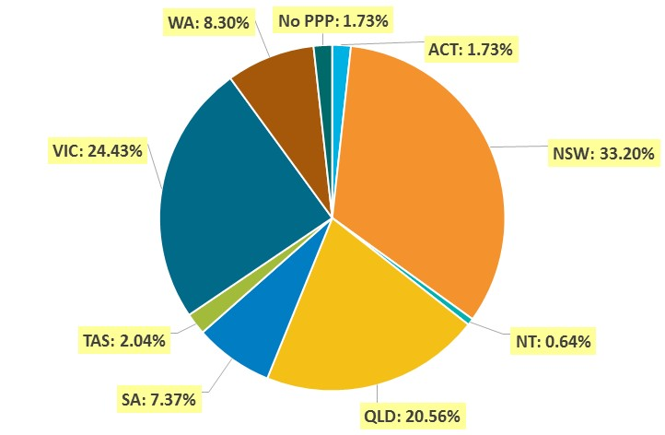

- Divisions
  - By area of division
Divisions | ACT | NSW | NT | QLD | SA | TAS | VIC | WA | No PPP | Total
Diagnostic Radiographer | 197 | 4,104 | 90 | 2,597 | 958 | 246 | 2,962 | 1,091 | 220 | 12,465
Diagnostic Radiographer and Nuclear Medicine Technologist |  | 2 |  | 10 | 1 | 1 | 1 | 2 |  | 17
Diagnostic Radiographer and Radiation Therapist |  |  |  | 1 |  |  | 1 |  |  | 2
Nuclear Medicine Technologist | 24 | 466 | 2 | 176 | 79 | 16 | 350 | 67 | 19 | 1,199
Radiation Therapist | 59 | 790 | 11 | 536 | 152 | 66 | 632 | 180 | 41 | 2,467
Total | 280 | 5,362 | 103 | 3,320 | 1,190 | 329 | 3,946 | 1,340 | 280 | 16,150

Age group
- Registration type and subtype
  - Registration by age group
Age Group | General | Provisional | Limited |  | Non-practising | Total
Age Group | General | Provisional | Post graduate training or supervised practice | Supervised Practice | Non-practising | Total
U - 25 | 1,102 | 291 |  |  | 2 | 1,395
25 - 29 | 2,950 | 149 |  |  | 45 | 3,144
30 - 34 | 2,834 | 34 | 1 |  | 50 | 2,919
35 - 39 | 2,120 | 25 |  |  | 41 | 2,186
40 - 44 | 1,619 | 7 |  |  | 43 | 1,669
45 - 49 | 1,384 | 6 |  |  | 15 | 1,405
50 - 54 | 1,078 | 3 |  |  | 15 | 1,096
55 - 59 | 1,067 | 1 |  |  | 16 | 1,084
60 - 64 | 823 |  |  | 1 | 14 | 838
65 - 69 | 331 |  |  |  | 5 | 336
70 - 74 | 55 |  |  |  | 7 | 62
75 - 79 | 14 |  |  |  | 1 | 15
80+ | 1 |  |  |  |  | 1
Total | 15,378 | 516 | 1 | 1 | 254 | 16,150

- Divisions
  - Divisions by age group
Age Group | Diagnostic Radiographer | Diagnostic Radiographer and Nuclear Medicine Technologist | Diagnostic Radiographer and Radiation Therapist | Nuclear Medicine Technologist | Radiation Therapist | Total
U - 25 | 1,022 |  |  | 159 | 214 | 1,395
25 - 29 | 2,395 | 1 |  | 258 | 490 | 3,144
30 - 34 | 2,116 |  |  | 224 | 579 | 2,919
35 - 39 | 1,620 | 4 |  | 176 | 386 | 2,186
40 - 44 | 1,264 | 3 | 1 | 128 | 273 | 1,669
45 - 49 | 1,108 | 5 | 1 | 98 | 193 | 1,405
50 - 54 | 922 | 2 |  | 57 | 115 | 1,096
55 - 59 | 908 | 2 |  | 42 | 132 | 1,084
60 - 64 | 724 |  |  | 45 | 69 | 838
65 - 69 | 312 |  |  | 9 | 15 | 336
70 - 74 | 59 |  |  | 2 | 1 | 62
75 - 79 | 14 |  |  | 1 |  | 15
80+ | 1 |  |  |  |  | 1
Total | 12,465 | 17 | 2 | 1,199 | 2,467 | 16,150

  - Registration by age group
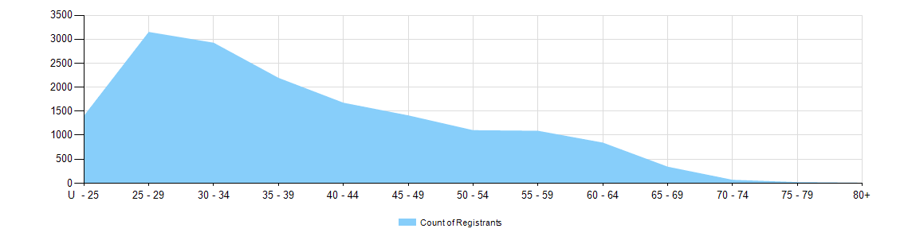

Gender
- Registration type
  - Registration type by gender
Gender | Registration Type | Subtype |  | ACT | NSW | NT | QLD | SA | TAS | VIC | WA | No PPP | Total
Female | General |  |  | 176 | 3,389 | 59 | 2,176 | 864 | 222 | 2,473 | 899 | 188 | 10,446
Female | Provisional |  |  | 1 | 186 | 3 | 34 | 1 | 3 | 117 | 5 |  | 350
Female | Limited |  | Postgraduate training or supervised practice |  |  |  |  |  |  |  |  | 1 | 1
Female | Non-practising |  |  | 5 | 45 | 2 | 19 | 13 | 5 | 64 | 13 | 27 | 193
Total Female |  |  |  | 182 | 3,620 | 64 | 2,229 | 878 | 230 | 2,654 | 917 | 216 | 10,990
Male | General |  |  | 95 | 1,633 | 37 | 1,067 | 310 | 98 | 1,218 | 418 | 56 | 4,932
Male | Provisional |  |  | 3 | 89 | 2 | 19 |  | 1 | 51 |  | 1 | 166
Male | Limited | Supervised practice |  |  |  |  |  | 1 |  |  |  |  | 1
Male | Non-practising |  |  |  | 20 |  | 5 | 1 |  | 23 | 5 | 7 | 61
Total Male |  |  |  | 98 | 1,742 | 39 | 1,091 | 312 | 99 | 1,292 | 423 | 64 | 5,160
Total |  |  |  | 280 | 5,362 | 103 | 3,320 | 1,190 | 329 | 3,946 | 1,340 | 280 | 16,150

- Percentage
  - Registration by gender percentages
Gender | ACT | NSW | NT | QLD | SA | TAS | VIC | WA | No PPP | Total
Female | 65.0% | 67.5% | 62.1% | 67.1% | 73.8% | 69.9% | 67.3% | 68.4% | 77.1% | 68.0%
Male | 35.0% | 32.5% | 37.9% | 32.9% | 26.2% | 30.1% | 32.7% | 31.6% | 22.9% | 32.0%

