

Medical Radiation Practice Board of Australia

Registrant Data

Reporting period: 1 April 2016 – 30 June 2016

Table of contents
Introduction 3
Principal Place of Practice 4
1. Registration Type 4
2. Divisions 5
Age Group 6
3. Registration Type and Sub type 6
Gender 7
4. Registration Type 7
5. Percentage 7

Introduction
The role of the Medical Radiation Practice Board of Australia (the Board) is to:
- register medical radiation practitioners and students
- develop standards, codes and guidelines for the medical radiation profession
- investigate notifications and complaints
- where necessary, conduct panel hearings and refer serious matters to Tribunal hearings
- oversee the assessment of overseas trained practitioners who wish to practise in Australia, and
- approve accreditation standards and accredited courses of study.
The Board’s functions are supported by the Australian Health Practitioner Regulation Agency (AHPRA). For information about legislation governing our operations see About AHPRA at http://www.ahpra.gov.au/About-AHPRA/What-We-Do/Legislation.aspx.
The Board has analysed its registration data and produced a number of statistical breakdowns about registrants to share with the profession and community. The Board shares these breakdowns regularly.
For more information on medical radiation practitioner registration, please see the Board’s website: http://www.medicalradiationpracticeboard.gov.au/Registration.aspx

Principal Place of Practice
- Registration Type
  - Registration type and sub type by principal place of practice
Registration Type | Sub Type | ACT | NSW | NT | QLD | SA | TAS | VIC | WA | No PPP | Total
General |  | 248 | 4,740 | 106 | 2,936 | 1,138 | 303 | 3,555 | 1,308 | 207 | 14,541
Provisional |  | 11 | 288 | 4 | 105 | 2 | 4 | 103 | 5 |  | 522
Limited | Postgraduate training or supervised practice |  | 1 |  |  |  |  | 2 |  | 3 | 6
Non-practising |  | 5 | 60 | 2 | 20 | 21 | 4 | 80 | 12 | 30 | 234
Total |  | 264 | 5,089 | 112 | 3,061 | 1,161 | 311 | 3,740 | 1,325 | 240 | 15,303

  - Registration type by principal place of practice percentages

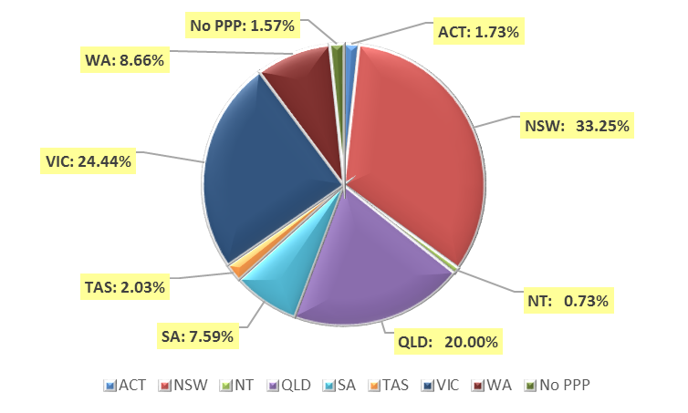

- Divisions
  - By area of division
Divisions | ACT | NSW | NT | QLD | SA | TAS | VIC | WA | No PPP | Total
Diagnostic Radiographer | 175 | 3,916 | 99 | 2,410 | 932 | 232 | 2,811 | 1,079 | 186 | 11,840
Diagnostic Radiographer and Nuclear Medicine Technologist |  | 1 |  | 10 | 1 | 1 |  | 1 |  | 14
Diagnostic Radiographer and Radiation Therapist |  |  |  | 1 |  |  | 1 |  |  | 2
Nuclear Medicine Technologist | 25 | 422 | 2 | 153 | 80 | 20 | 317 | 66 | 10 | 1,095
Radiation Therapist | 64 | 750 | 11 | 487 | 148 | 58 | 611 | 179 | 44 | 2,352
Total | 264 | 5,089 | 112 | 3,061 | 1,161 | 311 | 3,740 | 1,325 | 240 | 15,303

Age Group
- Registration Type and Sub type
  - Registration by age group
Age Group | General | Provisional | Limited | Non-practising | Total
Age Group | General | Provisional | Post graduate training or supervised practice | Non-practising | Total
U - 25 | 1,103 | 333 |  | 5 | 1,441
25 - 29 | 2,886 | 124 | 2 | 41 | 3,053
30 - 34 | 2,632 | 32 | 3 | 60 | 2,727
35 - 39 | 1,869 | 14 |  | 41 | 1,924
40 - 44 | 1,595 | 12 |  | 28 | 1,635
45 - 49 | 1,241 | 2 | 1 | 10 | 1,254
50 - 54 | 1,050 | 5 |  | 13 | 1,068
55 - 59 | 1,098 |  |  | 18 | 1,116
60 - 64 | 721 |  |  | 10 | 731
65 - 69 | 275 |  |  | 5 | 280
70 - 74 | 55 |  |  | 2 | 57
75 - 79 | 16 |  |  | 1 | 17
80+
Total | 14,541 | 522 | 6 | 234 | 15,303

  - Registration by age group
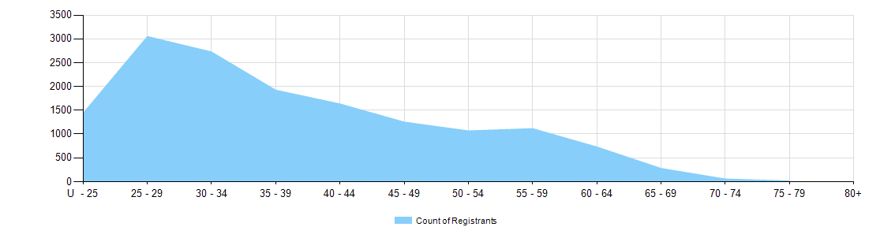

Gender
- Registration Type
  - Registration type by gender
Gender | Registration Type | Sub Type |  | ACT | NSW | NT | QLD | SA | TAS | VIC | WA | No PPP | Total
Female | General |  |  | 160 | 3,174 | 68 | 1,972 | 829 | 206 | 2,378 | 899 | 146 | 9,832
Female | Provisional |  |  | 11 | 193 | 2 | 74 | 1 | 3 | 64 | 3 |  | 351
Female | Limited |  | Postgraduate training or supervised practice |  |  |  |  |  |  |  |  | 3 | 3
Female | Non-practising |  |  | 5 | 48 | 2 | 13 | 20 | 4 | 58 | 10 | 23 | 183
Total Female |  |  |  | 176 | 3,415 | 72 | 2,059 | 850 | 213 | 2,500 | 912 | 172 | 10,369
Male | General |  |  | 88 | 1,566 | 38 | 964 | 309 | 97 | 1,177 | 409 | 61 | 4,709
Male | Provisional |  |  |  | 95 | 2 | 31 | 1 | 1 | 39 | 2 |  | 171
Male | Limited | Postgraduate training or supervised practice |  |  | 1 |  |  |  |  | 2 |  |  | 3
Male | Non-practising |  |  |  | 12 |  | 7 | 1 |  | 22 | 2 | 7 | 51
Total Male |  |  |  | 88 | 1,674 | 40 | 1,002 | 311 | 98 | 1,240 | 413 | 68 | 4,934
Total |  |  |  | 264 | 5,089 | 112 | 3,061 | 1,161 | 311 | 3,740 | 1,325 | 240 | 15,303

- Percentage
  - Registration by gender percentages
Gender | ACT | NSW | NT | QLD | SA | TAS | VIC | WA | No PPP | Total
Female | 66.7% | 67.1% | 64.3% | 67.3% | 73.2% | 68.5% | 66.8% | 68.8% | 71.7% | 67.8%
Male | 33.3% | 32.9% | 35.7% | 32.7% | 26.8% | 31.5% | 33.2% | 31.2% | 28.3% | 32.2%

