

Medical Radiation Practice Board of Australia

Registrant Data

Reporting period: 1 April 2017 – 30 June 2017

Table of contents
Introduction 3
Principal Place of Practice 4
1. Registration Type 4
2. Divisions 5
Age Group 6
3. Registration Type and Sub type 6
4. Divisions 7
Gender 8
5. Registration Type 8
6. Percentage 8

Introduction
The role of the Medical Radiation Practice Board of Australia (the Board) is to:
- register medical radiation practitioners and students
- develop standards, codes and guidelines for the medical radiation profession
- investigate notifications and complaints
- where necessary, conduct panel hearings and refer serious matters to Tribunal hearings
- oversee the assessment of overseas trained practitioners who wish to practise in Australia, and
- approve accreditation standards and accredited courses of study.
The Board’s functions are supported by the Australian Health Practitioner Regulation Agency (AHPRA). For information about legislation governing our operations see About AHPRA at www.ahpra.gov.au/About-AHPRA/What-We-Do/Legislation.aspx.
The Board has analysed its registration data and produced a number of statistical breakdowns about registrants to share with the profession and community. The Board shares these breakdowns regularly.
For more information on medical radiation practitioner registration, please see the Board’s website: www.medicalradiationpracticeboard.gov.au/Registration.aspx

Principal Place of Practice
- Registration Type
  - Registration type and sub type by principal place of practice
Registration Type | Sub Type | ACT | NSW | NT | QLD | SA | TAS | VIC | WA | No PPP | Total
General |  | 252 | 4,925 | 102 | 3,084 | 1,163 | 307 | 3,642 | 1,310 | 225 | 15,010
Provisional |  | 5 | 237 | 3 | 61 | 1 | 1 | 121 | 7 | 1 | 437
Limited | Postgraduate training or supervised practice |  |  |  |  |  |  |  |  | 1 | 1
Non-practising |  | 4 | 55 | 2 | 22 | 14 | 4 | 81 | 18 | 35 | 235
Total |  | 261 | 5,217 | 107 | 3,167 | 1,178 | 312 | 3,844 | 1,335 | 262 | 15,683

  - Registration type by principal place of practice percentages

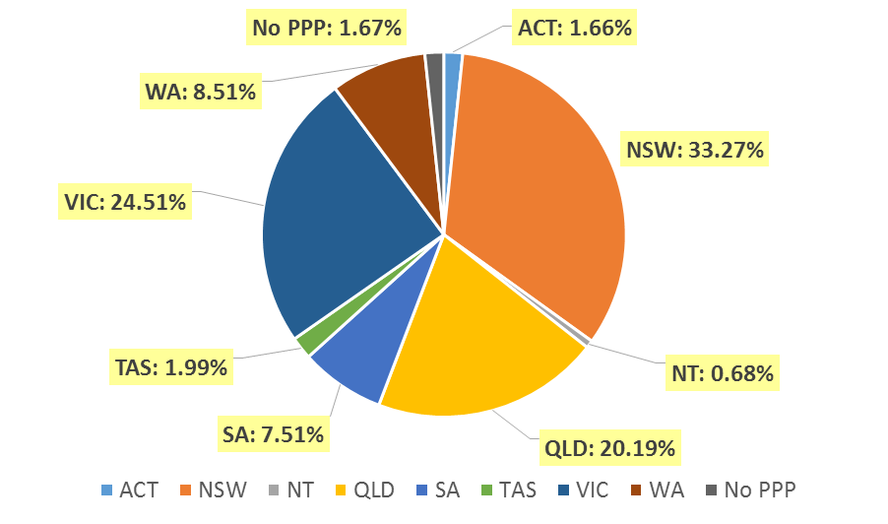

- Divisions
  - By area of division
Divisions | ACT | NSW | NT | QLD | SA | TAS | VIC | WA | No PPP | Total
Diagnostic Radiographer | 179 | 3,991 | 93 | 2,480 | 949 | 235 | 2,897 | 1,091 | 202 | 12,117
Diagnostic Radiographer and Nuclear Medicine Technologist |  | 2 |  | 10 | 1 | 1 | 1 | 1 | 1 | 17
Diagnostic Radiographer and Radiation Therapist |  |  |  | 1 |  |  | 1 |  |  | 2
Nuclear Medicine Technologist | 23 | 441 | 2 | 162 | 78 | 16 | 338 | 67 | 18 | 1,145
Radiation Therapist | 59 | 783 | 12 | 514 | 150 | 60 | 607 | 176 | 41 | 2,402
Total | 261 | 5,217 | 107 | 3,167 | 1,178 | 312 | 3,844 | 1,335 | 262 | 15,683

Age Group
- Registration Type and Sub type
  - Registration by age group
Age Group | General | Provisional | Limited | Non-practising | Total
Age Group | General | Provisional | Post graduate training or supervised practice | Non-practising | Total
U - 25 | 1,148 | 249 |  | 4 | 1,401
25 - 29 | 2,904 | 120 |  | 44 | 3,068
30 - 34 | 2,762 | 30 | 1 | 55 | 2,848
35 - 39 | 2,017 | 20 |  | 38 | 2,075
40 - 44 | 1,603 | 9 |  | 35 | 1,647
45 - 49 | 1,317 | 5 |  | 9 | 1,331
50 - 54 | 1,078 | 3 |  | 14 | 1,095
55 - 59 | 1,080 | 1 |  | 17 | 1,098
60 - 64 | 754 |  |  | 11 | 765
65 - 69 | 284 |  |  | 3 | 287
70 - 74 | 49 |  |  | 4 | 53
75 - 79 | 13 |  |  | 1 | 14
80+ | 1 |  |  |  | 1
Total | 15,010 | 437 | 1 | 235 | 15,683

- Divisions
  - Divisions by age group
Age Group | Diagnostic Radiographer | Diagnostic Radiographer and Nuclear Medicine Technologist | Diagnostic Radiographer and Nuclear Medicine Technologist | Nuclear Medicine Technologist | Radiation Therapist | Total
U - 25 | 1,052 |  |  | 139 | 210 | 1,401
25 - 29 | 2,315 | 1 |  | 255 | 497 | 3,068
30 - 34 | 2,066 |  |  | 214 | 568 | 2,848
35 - 39 | 1,537 | 5 |  | 169 | 364 | 2,075
40 - 44 | 1,247 | 3 | 1 | 127 | 269 | 1,647
45 - 49 | 1,053 | 4 | 1 | 95 | 178 | 1,331
50 - 54 | 926 | 2 |  | 54 | 113 | 1,095
55 - 59 | 922 | 2 |  | 43 | 131 | 1,098
60 - 64 | 670 |  |  | 37 | 58 | 765
65 - 69 | 264 |  |  | 10 | 13 | 287
70 - 74 | 51 |  |  | 1 | 1 | 53
75 - 79 | 13 |  |  | 1 |  | 14
80+ | 1 |  |  |  |  | 1
Total | 12,117 | 17 | 2 | 1,145 | 2,402 | 15,683

  - Registration by age group
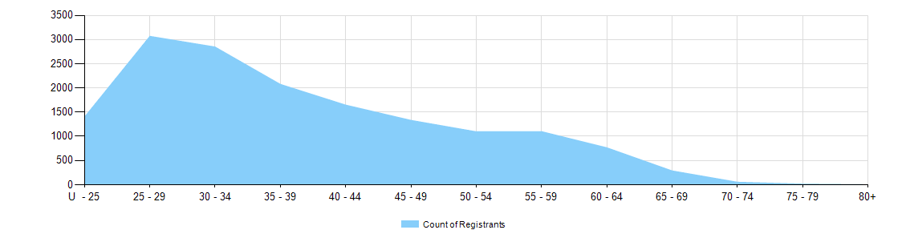

Gender
- Registration Type
  - Registration type by gender
Gender | Registration Type | Sub Type |  | ACT | NSW | NT | QLD | SA | TAS | VIC | WA | No PPP | Total
Female | General |  |  | 167 | 3,319 | 60 | 2,066 | 858 | 210 | 2,437 | 896 | 167 | 10,180
Female | Provisional |  |  | 3 | 167 | 1 | 41 |  | 1 | 85 | 6 |  | 304
Female | Limited |  | Postgraduate training or supervised practice |  |  |  |  |  |  |  |  | 1 | 1
Female | Non-practising |  |  | 4 | 41 | 2 | 17 | 13 | 4 | 58 | 13 | 27 | 179
Total Female |  |  |  | 174 | 3,527 | 63 | 2,124 | 871 | 215 | 2,580 | 915 | 195 | 10,664
Male | General |  |  | 85 | 1,606 | 42 | 1,018 | 305 | 97 | 1,205 | 414 | 58 | 4,830
Male | Provisional |  |  | 2 | 70 | 2 | 20 | 1 |  | 36 | 1 | 1 | 133
Male | Limited | Postgraduate training or supervised practice |  |  | 2 |  |  |  |  |  |  |  | 2
Male | Non-practising |  |  |  | 14 |  | 5 | 1 |  | 23 | 5 | 8 | 56
Total Male |  |  |  | 87 | 1,690 | 44 | 1,043 | 307 | 97 | 1,264 | 420 | 67 | 5,019
Total |  |  |  | 261 | 5,217 | 107 | 3,167 | 1,178 | 312 | 3,844 | 1,335 | 262 | 15,683

- Percentage
  - Registration by gender percentages
Gender | ACT | NSW | NT | QLD | SA | TAS | VIC | WA | No PPP | Total
Female | 66.7% | 67.6% | 58.9% | 67.1% | 73.9% | 68.9% | 67.1% | 68.5% | 74.4% | 68.0%
Male | 33.3% | 32.4% | 41.1% | 32.9% | 26.1% | 31.1% | 32.9% | 31.5% | 25.6% | 32.0%

