

Medical Radiation Practice Board of Australia

Registrant data

Reporting period: 1 October 2018 – 31 December 2018

Table of contents
Introduction 3
Principal place of practice 4
1. Registration type 4
2. Divisions 5
Age group 6
3. Registration type and subtype 6
4. Divisions 7
Gender 8
5. Registration type 8
6. Percentage 8

Introduction
The role of the Medical Radiation Practice Board of Australia (the Board) is to:
- register medical radiation practitioners and students
- develop standards, codes and guidelines for the medical radiation profession
- investigate notifications and complaints
- where necessary, conduct panel hearings and refer serious matters to Tribunal hearings
- oversee the assessment of overseas trained practitioners who wish to practise in Australia, and
- approve accreditation standards and accredited courses of study.
The Board’s functions are supported by the Australian Health Practitioner Regulation Agency (AHPRA). For information about legislation governing our operations see About AHPRA at www.ahpra.gov.au/About-AHPRA/What-We-Do/Legislation.aspx.
The Board has analysed its registration data and produced a number of statistical breakdowns about registrants to share with the profession and community. The Board shares these breakdowns regularly.
For more information on medical radiation practitioner registration, please see the Board’s website: www.medicalradiationpracticeboard.gov.au/Registration.aspx

Principal place of practice
- Registration type
  - Registration type and subtype by principal place of practice
Registration type | Subtype | ACT | NSW | NT | QLD | SA | TAS | VIC | WA | No PPP | Total
General |  | 272 | 5,194 | 112 | 3,366 | 1,261 | 329 | 3,861 | 1,381 | 251 | 16,027
Provisional |  | 4 | 245 | 11 | 69 | 6 | 4 | 153 | 5 |  | 497
Limited | Postgraduate training or supervised practice |  |  |  |  |  |  | 1 |  |  | 1
Limited | Supervised practice |  |  |  |  | 1 |  |  |  |  | 1
Non-practising |  | 9 | 72 | 1 | 23 | 15 | 4 | 76 | 16 | 33 | 249
Total |  | 285 | 5,511 | 124 | 3,458 | 1,283 | 337 | 4,091 | 1,402 | 284 | 16,775

  - Principal place of practice percentages

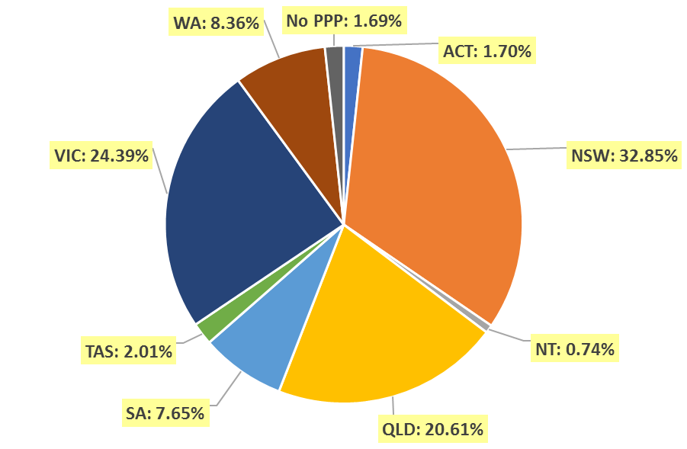

- Divisions
  - By area of division
Divisions | ACT | NSW | NT | QLD | SA | TAS | VIC | WA | No PPP | Total
Diagnostic Radiographer | 199 | 4,251 | 110 | 2,717 | 1,030 | 249 | 3,087 | 1,135 | 236 | 13,014
Diagnostic Radiographer and Nuclear Medicine Technologist |  | 2 |  | 9 | 1 | 1 | 1 | 2 | 1 | 17
Diagnostic Radiographer and Radiation Therapist |  |  |  | 1 |  |  | 1 |  |  | 2
Nuclear Medicine Technologist | 28 | 457 | 3 | 183 | 91 | 17 | 358 | 67 | 14 | 1,218
Radiation Therapist | 58 | 801 | 11 | 548 | 161 | 70 | 644 | 198 | 33 | 2,524
Total | 285 | 5,511 | 124 | 3,458 | 1,283 | 337 | 4,091 | 1,402 | 284 | 16,775

Age group
- Registration type and subtype
  - Registration by age group
Age Group | General | Provisional | Limited |  | Non-practising | Total
Age Group | General | Provisional | Post graduate training or supervised practice | Supervised Practice | Non-practising | Total
U - 25 | 1,190 | 300 |  |  | 2 | 1,492
25 - 29 | 3,050 | 125 |  |  | 40 | 3,215
30 - 34 | 2,947 | 34 |  |  | 48 | 3,029
35 - 39 | 2,288 | 16 |  |  | 47 | 2,351
40 - 44 | 1,652 | 12 | 1 |  | 41 | 1,706
45 - 49 | 1,442 | 6 |  |  | 21 | 1,469
50 - 54 | 1,085 | 2 |  |  | 13 | 1,100
55 - 59 | 1,083 | 2 |  |  | 13 | 1,098
60 - 64 | 859 |  |  | 1 | 13 | 873
65 - 69 | 341 |  |  |  | 6 | 347
70 - 74 | 73 |  |  |  | 4 | 77
75 - 79 | 15 |  |  |  | 1 | 16
80+ | 2 |  |  |  |  | 2
Total | 16,027 | 497 | 1 | 1 | 249 | 16,775

- Divisions
  - Divisions by age group
Age Group | Diagnostic Radiographer | Diagnostic Radiographer and Nuclear Medicine Technologist | Diagnostic Radiographer and Radiation Therapist | Nuclear Medicine Technologist | Radiation Therapist | Total
U - 25 | 1,118 |  |  | 141 | 233 | 1,492
25 - 29 | 2,485 | 1 |  | 261 | 468 | 3,215
30 - 34 | 2,233 |  |  | 228 | 568 | 3,029
35 - 39 | 1,729 | 4 |  | 191 | 427 | 2,351
40 - 44 | 1,298 | 3 | 1 | 135 | 269 | 1,706
45 - 49 | 1,136 | 5 | 1 | 100 | 227 | 1,469
50 - 54 | 924 | 2 |  | 61 | 113 | 1,100
55 - 59 | 927 | 1 |  | 47 | 123 | 1,098
60 - 64 | 753 | 1 |  | 42 | 77 | 873
65 - 69 | 319 |  |  | 10 | 18 | 347
70 - 74 | 75 |  |  | 1 | 1 | 77
75 - 79 | 15 |  |  | 1 |  | 16
80+ | 2 |  |  |  |  | 2
Total | 13,014 | 17 | 2 | 1,218 | 2,524 | 16,775

  - Registration by age group

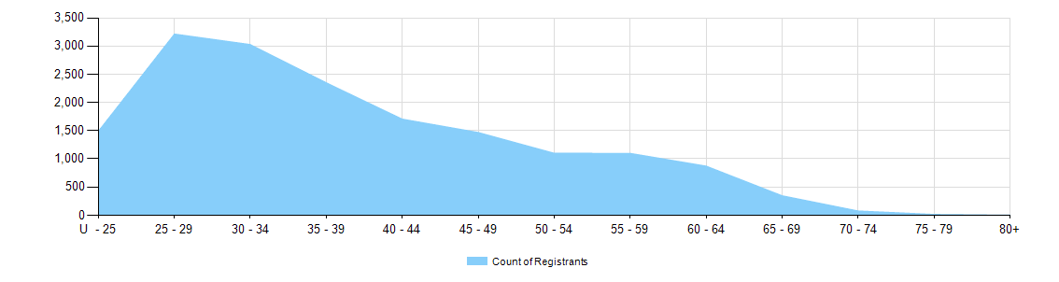

Gender
- Registration type
  - Registration type by gender
Gender | Registration Type | Subtype | ACT | NSW | NT | QLD | SA | TAS | VIC | WA | No PPP | Total
Female | General |  | 183 | 3,518 | 70 | 2,266 | 931 | 227 | 2,587 | 953 | 181 | 10,916
Female | Provisional |  |  | 167 | 7 | 45 | 4 | 3 | 111 | 5 |  | 342
Female | Limited | Postgraduate training or supervised practice |  |  |  |  |  |  | 1 |  |  | 1
Female | Non-practising |  | 9 | 54 | 1 | 19 | 12 | 4 | 56 | 13 | 26 | 194
Total Female |  |  | 192 | 3,739 | 78 | 2,330 | 947 | 234 | 2,755 | 971 | 207 | 11,453
Male | General |  | 89 | 1,676 | 42 | 1,100 | 330 | 102 | 1,274 | 428 | 70 | 5,111
Male | Provisional |  | 4 | 78 | 4 | 24 | 2 | 1 | 42 |  |  | 155
Male | Limited | Supervised practice |  |  |  |  | 1 |  |  |  |  | 1
Male | Non-practising |  |  |  | 18 |  | 4 | 3 |  | 20 | 3 | 7
Total Male |  |  | 93 | 1,772 | 46 | 1,128 | 336 | 103 | 1,336 | 431 | 77 | 5,322
Total |  |  | 285 | 5,511 | 124 | 3,458 | 1,283 | 337 | 4,091 | 1,402 | 284 | 16,775

- Percentage
  - Registration by gender percentages
Gender | ACT | NSW | NT | QLD | SA | TAS | VIC | WA | No PPP | Total
Female | 67.4% | 67.8% | 62.9% | 67.4% | 73.8% | 69.4% | 67.3% | 69.3% | 72.9% | 68.3%
Male | 32.6% | 32.2% | 37.1% | 32.6% | 26.2% | 30.6% | 32.7% | 30.7% | 27.1% | 31.7%

